**LITERATURE REVIEW**

**2.1 INTRODUCTION**

Shopping is an activity aimed at collecting information about goods & services or purchasing of goods & services. The search processes give shoppers an opportunity to ensure that they take the right decision. Shopping involves a “see-touch-feel-select” sequence. The degree to which the shoppers follow the whole or part of this process varies with brand, product category, and other elements of the marketing mix.

There exist various categories of shoppers or consumers based on various criteria including behavior & attitude, purchase intention, purchase orientation, etc. This research seeks to build and implement a shopping mall that is striking enough to capture a good range of shoppers’ needs as well as provide unified access to varieties of goods and services from stores and other business establishments located jointly in a particular place using a software solution.

**2.2 HISTORICAL BACKGROUND**

The internet has brought about advancement in retail transactions through the enabling of online shopping malls (e-tailing or web shopping) (Kwek , Jalan, Lau, & Tan, 2010). Web shopping is the process by which consumers go through to purchase products or services over the Internet. The terms online-shop, Internet-shop, web-shop and online-store are used interchangeably in the extant literature. Web shopping is an e-commerce system used by shoppers in the context of business-to-consumer (B2C) or business-to-business (B2B) (Kwek , Jalan, Lau, & Tan, 2010). There has been an upsurge in the population of people who make use of online means of carrying out various activities from studying (e-learning), commerce (e-commerce), entertainment, tourism, sports, etc. There are various motives that may have informed these decisions of taking to online means of doing things. This has further influenced the choice of this project to investigate into the ways by which the online platform has been beneficial to the shopping process and also to establish the potential graces that online shopping malls have in stock for commercial activities. In order to further fill the gap between users of shopping malls and the shopping malls, there is intent to design and implement an online shopping mall that can enhance customers’ access to goods and commodities.

**2.3 THEORETICAL COVERAGE OF CONSTITUENT TERMINOLOGIES**

**2.3.1 SHOPPING**

As earlier introduced, Shopping is an activity aimed at collecting information or obtaining products. Shopping involves a “see-touch-feel-select” sequence. Shopping can either take place in a physical location or in a virtual space such as obtained over the Internet.

**2.3.2 ONLINE SHOPPING**

**2.3.3 SHOPPING MALLS**

This is a worldwide phenomenon that has its origins from ancient outdoor markets where people or customers buy food items from farmers or craftsmen. Shopping malls as we know today begun at the beginning of the 20th century and these shopping malls have grown to major parts of the world. Shopping malls have grown beyond the point of just a place for buying and selling, it can also be seen as a muster point where people come to interact with one another.

**2.3.4 CUSTOMERS**

In this context, consumers refer to potential consumers of the various goods and services offered by shopping malls. The aim of the development of an online shopping mall is to strive at providing convenience for customers involved in purchasing goods in the market. Online shopping malls create a form of relaxed and stress-free environment for buying and selling. To access these interface, customers would need a device that that can browse the internet (computers, phones, tablets etc.), customers would also need to have little knowledge of how to peruse the internet and also a means of payment (debit card) if customers prefer to pay online rather than pay on delivery.

**2.4 MEANS OF PAYMENT**

Due to the fact that the shopping environment is an online one, there has to be an interface provided for the needed transactions. The list of acceptable payment modes are discussed below and are classified into two:

**2.4.1 PAYMENT ON DELIVERY**

* Cheques: This can be issued as a means of payment to the deliverer of the good or service.
* Cash on delivery: This is very acceptable means of payment. This method of payment clears any form of doubt the deliverer has with the payment process. This is because the deliverer of the item is physically seeing the means by which the customer is using to pay and has the luxury of validating.

**2.4.2 E-TRANSACTION SYSTEMS**

This is a system of financial exchange between buyers and sellers in the virtual environment that is aided by a digital financial instrument (smart cards, credit cards, e-checks) backed up by legal tender or an intermediary. Under this, we have different innovation views:

* Innovations affecting the customers include credit and debit cards, automated teller machines (ATMs), e-banking and stored value cards.
* Innovations enabling online commerce: This type is not common in many developing countries but it is implemented in large organizations with secure channels for transaction. (Edesiri & Promise, 2013)

Though the use of e-transaction makes it easy for payment to occur, it also has its risks. These risks are discussed below.

**2.4.3 RISKS INVOLVED IN E-TRANSACTION**

* **Fraud risk associated with e-transaction:** This is a rapidly growing risk involved in the world of finance today. This is caused by poor internal controls, poor personnel policies and practices and also lack of honesty at the top level of management (Edesiri & Promise, 2013). This can only be prevented and controlled, not totally eradicated.
* **Money laundering associated with e-transaction:** This is also something that has been taken into consideration by customers. Money laundering is defined as the act of masking the ownership of illegally acquired assets to make them appear lawful (Edesiri & Promise, 2013).

E-transaction is still the way despite risks involved and the following recommendations have been made by Edesiri and Promise:

* Review the role of issuers and consumers to hinder security threats: there should be proper monitoring of e-payment channels by issuers of electronic transaction by constant upgrade of hardware and software to ensure security.
* Identify ways to increasing interests among businesses: giving attractive discounts to patriots of online shopping platforms.
* Reduce the usage of traditional payment methods: discourage the use of cash transactions and paper records during financial transactions (Edesiri & Promise, 2013).

**2.5 CATEGORIES OF CUSTOMERS**

1. Based on patronage behavior and reaction, we have:
2. Adjusting: these type of shoppers speak on the mild tone despite the fact that the product they bought was defective.
3. Authoritative: these type of shoppers asked for favors, discounts. They make the salesmen work double, run around. They tend to put pressure on the salesmen by asking too many questions. They sometimes scold the salesperson.
4. Ambience Seeker: This group of shoppers enjoy the shop atmosphere. They keep on looking at various displays and windows. They hang around, see, read, and listen to all what is on display.
5. Variety Seeker: They look for various options and ask for more variety of the same product. Such shoppers observed all the racks. They would see many items before selecting.
6. List Driven: These shoppers come with a list and buy only from lists. They do not look around much, nor try any product. They are also oblivious to the displays on racks. Such shoppers do not ask for options (Kwek , Jalan, Lau, & Tan, 2010).

**2.6 TYPES OF SHOPPING CENTERS**

Shopping centers are classified into four: General-purpose centers, Specialized-purpose centers, Limited-purpose centers and Total industry.

**2.6.1 GENERAL PURPOSE CENTERS**

1. Regional mall: This type of mall is enclosed with inward-facing stores and parking surrounds the outside perimeter.
2. Neighborhood center: This type of mall is convenience oriented.
3. Community center: This type of center is usually set in a straight line manner and provides other soft goods offerings than the neighborhood center.
4. Super-Regional mall: It is similar to the regional mall but provides more variety and assortment.

**2.6.2 SPECIALIZED PURPOSE CENTERS**

1. Factory outlet: Here, goods with brand names are sold at a particular discount by manufacturers and retailers.
2. Lifestyle: This type of centers are usually in outdoor settings in which dining and entertainment are made available.
3. Power centers: Consists of category-dominant anchors, discount department stores, off-price stores and so on.

**2.6.3 LIMITED PURPOSE CENTERS**

* **Airport retail**: This involves the merging of retail shops outside a commercial airport.

**2.6.4 TOTAL INDUSTRY**

This involves the combination of traditional, specialty and special purpose centers (ICSC Research and CoStar Realty Information, Inc., 2016)

The already known fact about shopping for an item is that we like to know what we are actually buying to set our mind at ease because of cases of expired goods, spoilt products and so on. This still goes back to customers physically shopping in various malls. There is the issue of security, intangibility of these online products, social contact, dissatisfaction with online shopping (Wang & Chayapa, 2011).These problems that discourages customers from shopping online would be discussed briefly.

**2.7 FACTORS THAT IMPEDE CUSTOMERS FROM SHOPPING ONLINE**

* **Security:** This is a major hindrance in the aspect of customers engaging in online shopping activities. Since the payment modes involved in online shopping are with the credit card, customers tend to pay higher attention to the sellers detail in order to protect themselves. In doing this, customers tend to go after the seller who they trust and also the brand they are conversant with (Wang & Chayapa, 2011)
* **Intangibility of online product:** As said earlier, customers want to be sure they are buying or purchasing the right product, not a product that has spoilt or is about to spoil or a product that has expired. For example, customers are less likely to purchase clothes online because they would not get that chance of examining the actual product until it is delivered to them (Wang & Chayapa, 2011).
* **Social contact:** Customers, sometimes, rely on other people’s opinion to make a decision on the kind of product they want to buy. This is when the presence of the professional salesperson is needed to support the customers in making the right decision.
* **Dissatisfaction with online shopping:** Most products delivered to customers might not be what they initially ordered online. This still comes back to the issue of trust. If for once a customer is offended or unhappy about a particular product ordered, it impedes the customer from either buying online from that particular site or even shopping online again (Wang & Chayapa, 2011).

All these factors mentioned now brings us to the question of why a customer would want to do away with all these hindrances and still consider or be motivates to perform their various shopping activities online. Some of the factors that motivate customers to shop online are discussed below.

**2.8 FACTORS MOTIVATING CUSTOMERS TO SHOP ONLINE**

For a customer or a consumer to decide to shop online, various options would have been taken into consideration in terms of why the customer should purchase an item online. Below are some of the reasons why some consumers might prefer acquiring online.

* **Convenience**: Research shows that the more convenient you are with the internet, the easier it is to decide to partake in online shopping activities. Unlike the traditional shops that have various closing hours, the online environment eradicates that limitation by being available 24 hours a day, 7 days a week . Also, most customers do not like the idea of crowds or waiting on queues to get a product or a service. Therefore, convenience is a key factor in the process of shopping.
* **Information**: The traditional means involved in purchasing goods and services included that the consumers would have a “touch and feel” experience of the product before buying it. This might serve as a slight limitation but if enough adequate information can be provided to customers to influence their decision of shopping online in a positive manner, it would influence more shoppers to engage in buying products online.
* **Available products and services**: Consumers would be at ease to know that almost any good or service needed would be found on a particular online shopping platform. This would encourage customers to go online and get their intended product and also have the option of choosing the sizes, colors or features. Also, good payment plans would be implemented in the websites and also the choice of picking the delivery date and choice of the payment mode.
* **Cost and Time efficiency:** Online shopping provides customers with discounts or provide lower prices to goods in which customers would play games or engage in hunts (online). This process makes the shopping process fun and entertaining. Now, in terms of time efficiency, it excludes customers from having to look for parking spaces in the physical shopping environment and also the issue of queue. Products would be delivered at the preference date the customer chooses (Wang & Chayapa, 2011).

**2.9 REVIEW OF RELATED WORKS**

**2.9.1 KONGA**

**2.9.1.1**

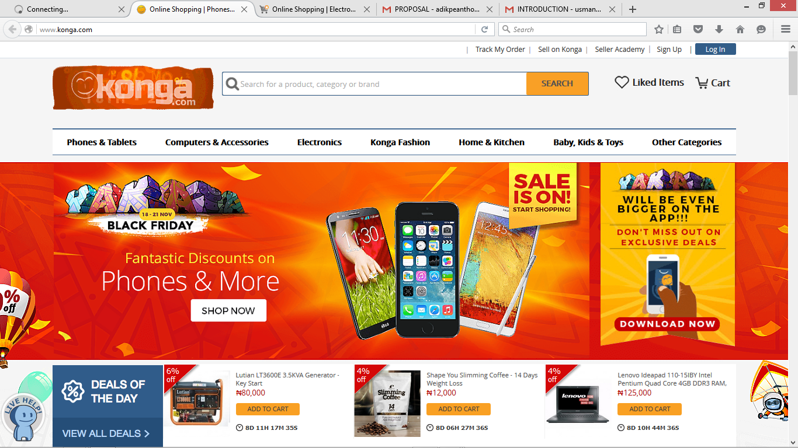

Figure 1

**2.9.1.2**

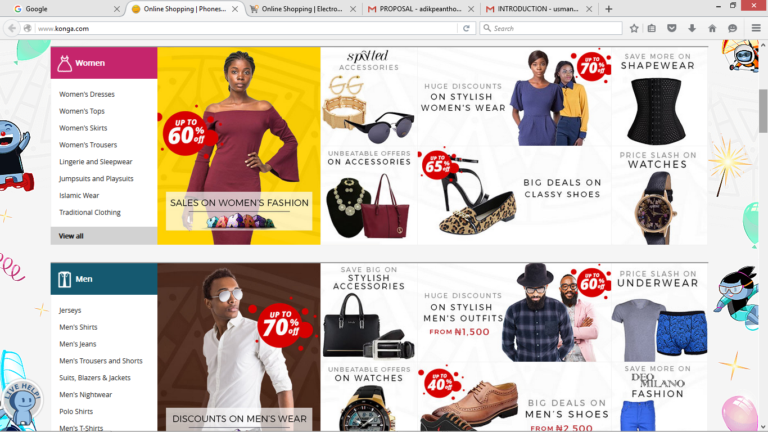

Figure 2

**2.9.2 JUMIA**

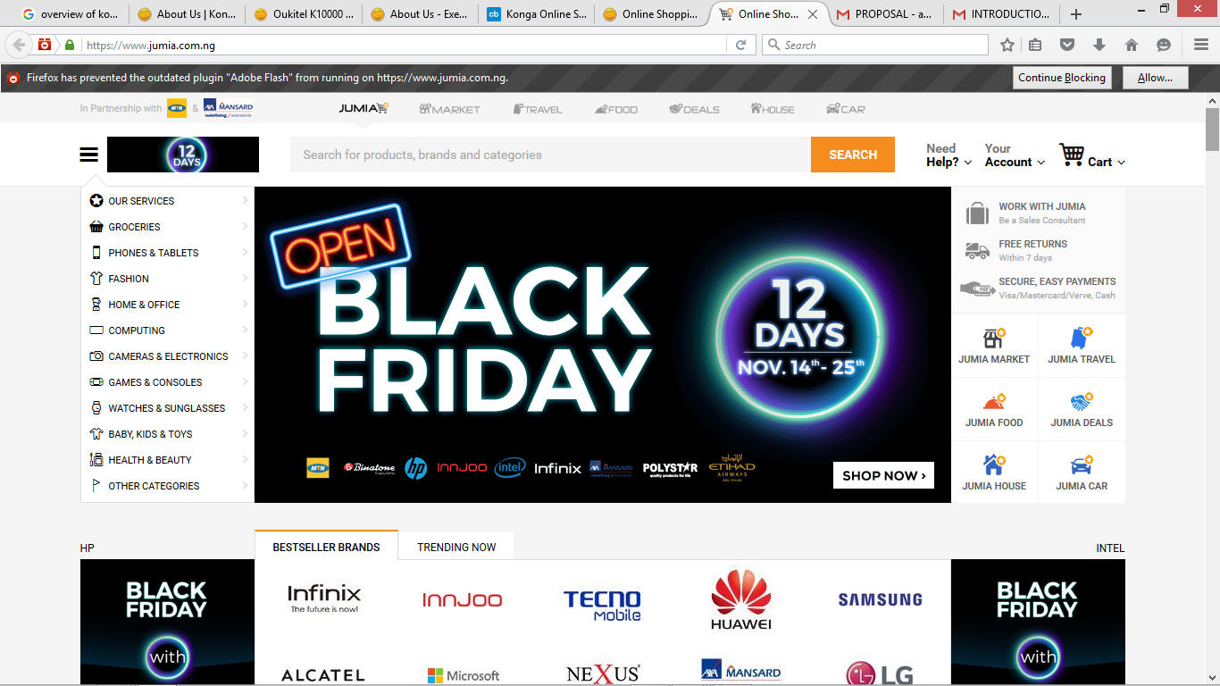

Figure 3

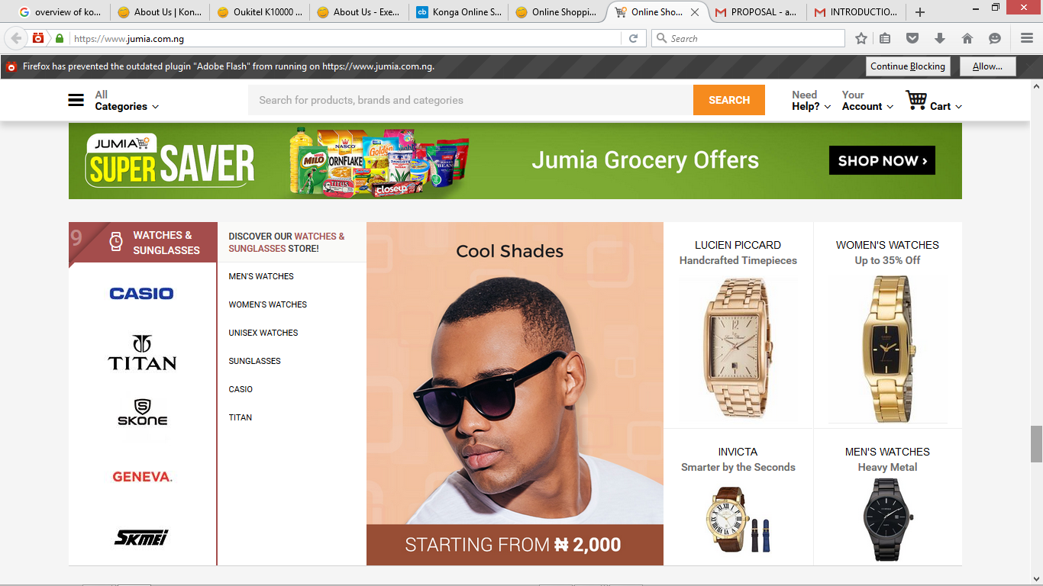

Figure 4

**2.9.3 JIJI**

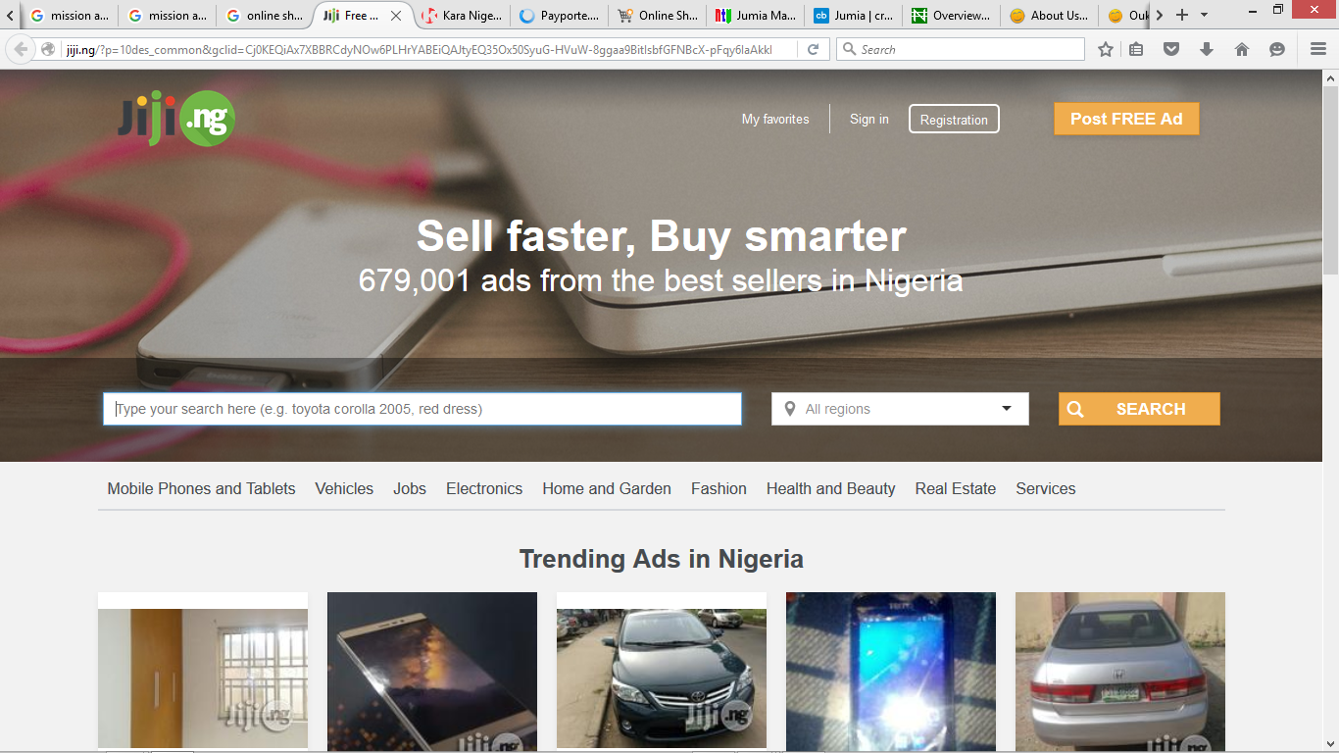

Figure 5

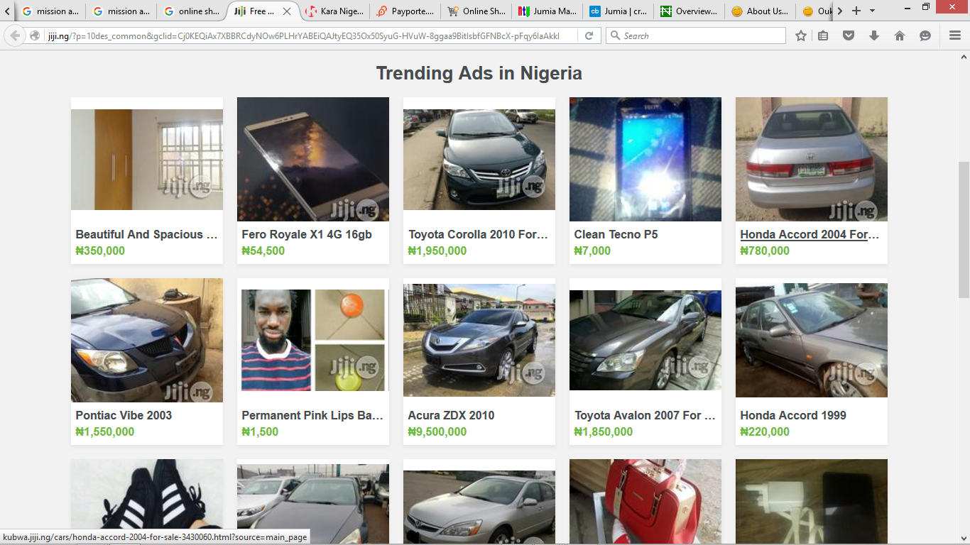

Figure 6

# Works Cited

Edesiri, G. O., & Promise, E. K. (2013). The problems and prospects of E-transaction (The Nigerian Perspective). *Journal of Research in International Business and Management, Vol. 3*(1 ), 10-16. Retrieved from http://www.interesjournals.org/JRIBM

ICSC Research and CoStar Realty Information, Inc. (2016, August). *U.S. Shopping-Center Classification and Characteristics.* Retrieved from ICSC Research and CoStar Realty Information, Inc . (www.costar.com)

Kwek , C. L., Jalan, M. G., Lau, T. C., & Tan, H. P. (2010, July). The Effects of Shopping Orientations, Online Trust and Prior Online Purchase Experience toward Customers’ Online Purchase Intention. *International Business Research, Vol. 3*( No. 3 ), 63-70. Retrieved from www.ccsenet.org/ibr

Wang, C. L., & Chayapa, K. (2011). Online Shopper Behavior: Influences of Online Shopping Decision. *Asian Journal of Business Research, 1*(2), 68-71.